**DIWALI SALES SQL QUERIES**

1.Overall Sales Analysis

1. Total Sales Revenue

Query: SELECT sum(amount) AS Total_Sales_Revenue from diwali_sales_data;

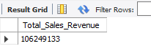

1. Total Orders Placed

Query: Select count(orders) AS Total_Orders_Placed from diwali_sales_data;

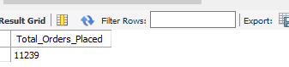

2.Product Analysis

1. Product Categories which Contributed the Most to Sales Revenue

Query: Select product_category, sum(amount) AS Total_Sales_Revenue from diwali_sales_data GROUP BY Product_Category ORDER BY Total_Sales_Revenue DESC LIMIT 5;

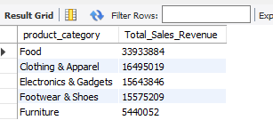

3.Customer Analysis

1. Distribution of customers across different age groups and genders

Query: Select COUNT(Age_Group), Gender from diwali_sales_data group by Gender, Age_Group;

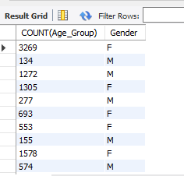

4. Geographical Analysis

1. Top-selling States or Zone

Query: SELECT State, Zone, SUM(Amount) AS Total_Sales_Revenue from diwali_sales_data GROUP BY State, Zone ORDER BY Total_Sales_Revenue DESC LIMIT 5;

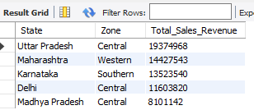

5.Demographic Analysis

1. Average age of customers

Query: SELECT AVG(Age) AS Average_Customers_Age from Diwali_sales-data;

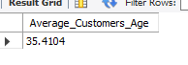

6.Order-Frequency Analysis

a. Average Number of Orders per Customer

Query: SELECT USER_ID, AVG(Orders) AS Average_Orders_per_Customer from diwali_sales_data GROUP BY User_ID;

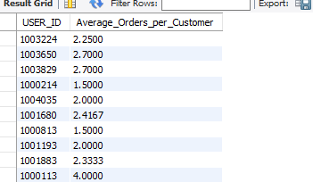

7.Revenue by Age-Group Analysis

1. Sales Revenue Variation Across Different Age Groups

Query: SELECT Age_Group, SUM(Amount) AS Total_Sales_Revenue from diwali_sales_data group by Age_Group ORDER BY Age_Group;

